# **QUIZ MASTERS**

*A*

*Mini Project Report*

*Submitted in partial fulfilment of the*

*Requirements for the award of the Degree of*

**BACHELOR OF ENGINEERING**

IN

**INFORMATION TECHNOLOGY**

By

GALI SUMASRI 1602-19-737-116

BASA RITHIKA 1602-19-737-088



**Department of Information Technology**

**Vasavi College of Engineering (Autonomous)**

**(Affiliated to Osmania University)**

**Ibrahimbagh, Hyderabad-31**

**2020**

**Vasavi College of Engineering**

**(Affiliated to Osmania University)**

**Hyderabad-500 031**

**Department of Information Technology**



**DECLARATION BY THE CANDIDATE**

We, SUMA SRI GALI and BASA RITHIKA bearing hall ticket numbers, 1602-19-737-116 and 1602-19-737-088, hereby declare that the project report entitled “QUIZ MASTERS” is submitted in partial fulfilment of the requirement for the award of the degree of Bachelor of Engineering in Information Technology.

This is a record of bonafide work carried out by us and the results embodied in this project report have not been submitted to any other university or institute for the award of any other degree or diploma.

SUMA SRI GALI

1602-19-737-116

BASA RITHIKA

1602-19-737-088

(Faculty In-Charge) (Head Dept IT)

**ACKNOWLEDGMENT**

We take this opportunity as a privilege to thank all the people without whose support and guidance we could not have completed our project in this stipulated period.

We extend our heartfelt thanks to our college, Vasavi College of Engineering, for providing the opportunity to implement our project, “QUIZ MASTERS”.

We convey thanks to our project guide **Mrs . Prasanna Dusi**, Assistant Professor of Information technology Department, Vasavi College of Engineering, for giving us their valuable guidance regarding our project work. We are indebted to her for the zeal she filled in us and the time spent with us to discuss various aspects on the project.

We are also grateful to our parents, for their love and kind support during this mini project.

**Abstract**

Many methods have been developed for gaining knowledge on various aspects. In those different aspects quizzes plays a major role to acquire the grasps on distinct platforms. A quiz is something which is the test of knowledge, especially as a competition between the individuals or as teams or for the form of the entertainment. In this advanced technology, online quizzes had got more vogue than the offline one.

Our project emphasizes on the online quiz, where we will be asking different questions on different genres and can acquire the knowledge in the two stages of quiz. In this quiz masters, there will be some coding questions even to know more about the programming languages. The user can view their highest scores and also reset their scores. While starting of the quiz, some of the tips and instructions will be given if needed on how to attempt the quiz.

TABLE OF CONTENTS

1.INTRODUCTION.........................................................................................1

2. TECHNOLOGY.........................................................................................2-3

2.1. SOFTWARE REQUIREMENTS ......................................................... 2

2.2. HARDWARE REQUIREMENTS.......................................................2,3

3. PROPOSED WORK ....................................................................................4-6

3.1. DESIGN.................................................................................................4

3.1.1. USER USE CASES............................................................................5,6

3.2. IMPLEMENTATION……………………………………………………

3.2.1. MODULE-WISE CODE..................................................... 6-39

3.2.2. GITHUB/FOLDER STRUCTURE ...................................... 39

3.3. TESTING ............................................................................. 40-51

4. RESULTS..................................................................................52-68

5. ADDITIONAL KNOWLEDGE GAINED……………………69

6. CONCLUSION AND FURTHUR WORK……………………70

7. REFERENCES…………………………………………………71

**INTRODUCTION**

A Quiz is a form of a game or mind sport in which users attempt to answer questions. It is a game to test knowledge about a certain topic.

Quiz Masters is an application in which people attempt to answer questions and gain knowledge from different genres through online. For users, we are making easy to grab the recognition in various themes and also we stumble the questions for different users who are attempting the quiz.

For the director’s point of view, the executive will be able to control the directions block by having all the registered names to hand and able to see the records of users.

This application helps the admin and users to do all the processes in an accurate way without no wasting of time. Quiz Masters also reduces the manual works to the user and can able to be get done the strive of quizzes at any time with the great efficiency. From this application we can also go through some other services like:

**.** To show the previous records

**.** Viewing the highest scores

**.** To reset the scores

**.** Help

**.** Main menu

**.** Helps admin to control each part of administration

**TECHNOLOGY**

Computer technology is leading to more accurate sizing and rating methods for process equipment. Computer technology consists of the hardware of computers and computer-controlled devices and software like the operating systems, authoring tools, expert systems, and courseware use to support training technology. Many institutions, government, charitable, and for-profit organizations often require technology development involving hardware or software design and the coordination of donors, distributors, and deplores. There are two different categories of this section

1. **Software requirements**

Software requirements deal with defining software resource requirements that need to be installed on the computer. These prerequisites are generally not included in the software installation package and need to be installed separately before the software is installed

The following sub-sections discuss the various aspects of software requirements for bike rental system.

* Web Browser: Microsoft Internet Explorer, Mozilla, Google Chrome or later
* Operating System: Windows XP / Windows7/ Windows Vista

1. **Hardware requirements**

The **hardware requirements** are the requirements of a hardware device. Most hardware only has operating system requirements or compatibility.

The following sub-sections discuss the various aspects of hardware requirements for bike rental system.

* 256 MB RAM
* 1 GB hard free drive space
* Processor: Intel Core I5 and more

**Proposed work**

1. **Design**
2. **Use case diagram and descriptions for all the use cases.**

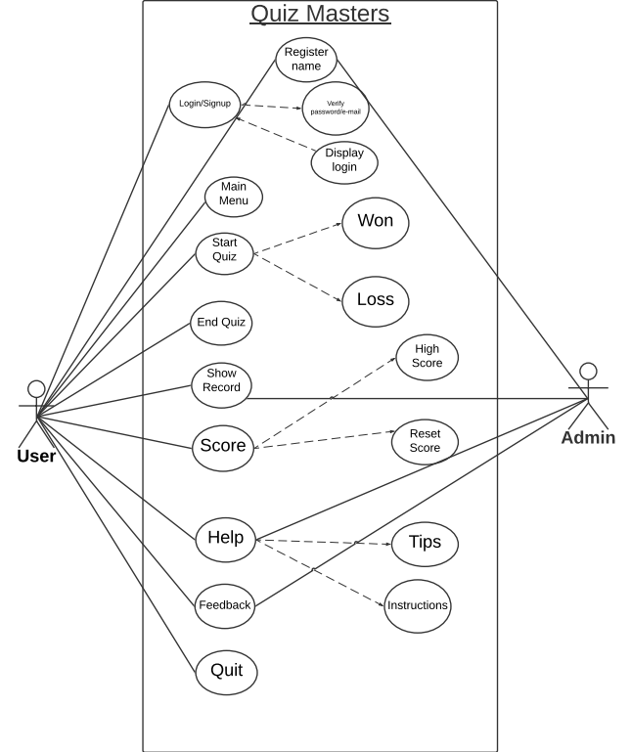

**Register the name:** User needs to register the name before attempting the quiz and make sure that he had given a valid username.

**Main Menu:** After successfully registering the name, the main menu will be displayed by the admin to choose the particular option on attempting the quiz.

In main menu we will be having various options to choose and to start the quiz, to know the scores which are highest, and also we will be having the option called reseting the scores.

**Start Quiz:** After registering the name and getting the main menu we can start the quiz. In this, we will be having 2 rounds such as warmup round and challenge round.

**1.Warm up round:** In this round, firstly the admin will be giving 10 questions and in those 10 questions the user need to answer at least 6 questions correctly. If not the user will be disqualified for the 2nd round.

**2. Challenge round:** In the 2nd round, the admin will be giving 30 questions to the user and the user need to answer all the answers correctly. If not he will be disqualified and gets the less points.

Finally, after total completion of attempting the quiz, user will get to know that he had WON or LOSS the quiz.

**NOTE: In this Quiz Masters, different users will be getting random questions from the quiz, so that everyone will not have the same order of questions and can maintain the tough competition between the users.**

**End Quiz:** While attempting the quiz, If the user gets 5 wrong answers in 1st round automatically the quiz will be ended. Whereas, If the user successfully completed the 1st round and entered into 2nd round, In 2nd round answering one question as wrong also leads to ending of the quiz.

**Show Record:** Show record is also same as the main menu, in which will be having the different score records which is operated by the admin.

**Score:** After successfully completion of attempting the quiz, the user score will be displayed of how many points he scored.

**Reset Score:**  In this module, user can reset all his previous scores and can start the quiz freshly by clearing his least scores and can get the new scores.

**Highest Scores:** In this module, any user can get to know what is the highest score among all the users.

**Help:** If the user had any confusion about the Quiz Masters, he can go through the help option and there, the admin will be displaying some tips and instructions to help the user in attempting the quiz.

**Quit:** Finally, after completion of the entire quiz and getting to know about all the scores and other modules, user can quit from the quiz.

**IMPLEMENTATION**

**Module wise code for the entire project**

#include<stdio.h>

#include<conio.h>

#include<ctype.h>

#include<stdlib.h>

#include<string.h>

void show_record();

void reset_score();

void help();

void edit_score(float,char[]);

int main()

{

int countr,r,r1,count,i,n;

float score;

char choice;

char playername[20];

mainhome:

printf("\t\t\t << QUIZ MASTERS >>\n");

printf("\n\t\t****************************************");

printf("\n\t\t\t WELCOME\n ");

printf("\n\t\t\t to\n ");

printf("\n\t\t\t THE QUIZ ");

printf("\n\t\t");

printf("\n\t\t****************************************");

printf("\n\t\t****************************************");

printf("\n\t\t > Press S to start the quiz");

printf("\n\t\t > Press V to view the highest score ");

printf("\n\t\t > Press R to reset score");

printf("\n\t\t > press H for help ");

printf("\n\t\t > press Q to quit ");

printf("\n\t\t________________________________________\n\n");

choice=toupper(getch());

if(choice=='V')

{

system("cls");

show_record();

system("cls");

goto mainhome;

}

else if(choice=='H')

{

system("cls");

help();

getch();

system("cls");

goto mainhome;

}

else if(choice=='R')

{

system("cls");

reset_score();

getch();

goto mainhome;

}

else if (choice=='Q')

{

exit(1);

}

else if(choice=='S')

{

system("cls");

printf("\n\n\n\n\n\n\n\n\n\n\t\t\tResister your name:");

gets(playername);

system("cls");

printf("\n *********** Welcome %s to Quiz Masters *****************",playername);

printf("\n\n Here are some tips you might wanna know before playing:");

printf("\n ********************************************************************************");

printf("\n >> There are 2 rounds in this Quiz,WARMUP ROUND & CHALLANGE ROUND");

printf("\n >> In warmup round you will be asked a total of 10 questions to test your");

printf("\n coding knowledge. You are eligible to play the quiz if you give atleast 6");

printf("\n right answers, otherwise you can't proceed further to the Challenge Round.");

printf("\n >> Your quiz starts with CHALLANGE ROUND. In this round you will be asked a");

printf("\n total of 10 questions. Each right answer will be awarded with 10 points!");

printf("\n By this way you can score upto 100 :-) :-):-):-):-):-):-)!!!!!..........");

printf("\n >> You will be given 4 options and you have to press A, B ,C or D for the");

printf("\n right option.");

printf("\n >> You will be asked questions continuously, till right answers are given");

printf("\n >> No negative marking for wrong answers!");

printf("\n\n\t!!!!!!!!!!!!! ALL THE BEST !!!!!!!!!!!!!");

printf("\n\n\n Press Y to start the quiz!\n");

printf("\n Press any other key to return to the main menu!");

if (toupper(getch())=='Y')

{

system("cls");

goto home;

}

else

{

system("cls");

goto mainhome;

}

home:

system("cls");

count=0;

_Bool arr[10]={0};

int A[10];

time_t t;

srand((unsigned)time(&t));

for(i=1; i<10; i++)

{

int r1 = rand()%10;

if(!arr[r1])

A[i]= r1;

else

i--;

arr[r1]=1;

}

for(i=1; i<10; i++)

{

switch(A[i])

{

case 1:

printf("\n\nA collecion of 8 bits are called?");

printf("\n\nA.bit\t\tB.word\n\nC.byte\t\tD.record");

if (toupper(getch())=='C')

{

printf("\n\nCorrect!!!");

count++;

getch();

system("cls");

break;

}

else

{

printf("\n\nWrong!!! The correct answer is C.byte");

getch();

system("cls");

break;

}

case 2:

printf("\n\nWhich of the following is a Palindrome number?");

printf("\n\nA.42042\t\tB.101010\n\nC.23232\t\tD.01234");

if (toupper(getch())=='C')

{

printf("\n\nCorrect!!!");

count++;

getch();

system("cls");

break;

}

else

{

printf("\n\nWrong!!! The correct answer is C.23232");

getch();

system("cls");

break;

}

system("cls");

case 3:

printf("\n\n\nWhich of the following is most oriented toward scientific programming ?");

printf("\n\nA.Cobol\t\tB.Fortran\n\nC.c++\t\tD.Basic");

if (toupper(getch())=='B')

{

printf("\n\nCorrect!!!");

count++;

getch();

system("cls");

break;

}

else

{

printf("\n\nWrong!!! The correct answer is B.Fortran");

getch();

system("cls");

break;

}

case 4:

printf("\n\nPredict the output of the following code\n\n void main()\n\n{\n\n int x=5\n\n if(x<1)\n\n printf('hello');\n\n if(x==5)\n\n printf('hi')n\n else\n\n printf('no')n\n}");

printf("\n\nA. hi\t\tB. no\n\nC. hello\t\tD. HELLO");

if(toupper(getch())=='A')

{

printf("\n\nCorrect!!!");

count++;

getch();

system("cls");

break;

}

else

{

printf("\n\nWrong!!! The correct answer is A.hi");

getch();

system("cls");

break;

}

case 5:

printf("\n\nWhich standard library function can return a pointer to the last occurence of a character in a string ?");

printf("\n\nA. stchar()\t\tB. strrchr()\n\nC. strchar() & stchar()\t\tD. strrchar() ");

if(toupper(getch())=='B')

{

printf("\n\nCorrect!!!");

count++;

getch();

system("cls");

break;

}

else

{

printf("\n\nWrong!!! The correct answer is B. strrchr()");

getch();

system("cls");

break;

}

case 6:

printf("\n\nWho developed C programming language ?");

printf("\n\nA.Bjarne Stroustrup\t\tB. James Gosling\n\nC. Dennis Ritchie\t\tD. Ray Boyce");

if(toupper(getch())=='C')

{

printf("\n\nCorrect!!!");

count++;

getch();

system("cls");

break;

}

else

{

printf("\n\nWrong!!! the correct answer is C. Dennis Ritchie");

getch();

system("cls");

break;

}

case 7:

printf("\n\nMaximum value of an unsigned integer is ?");

printf("\n\nA. 65535\t\tB. 32767\n\nC.-32767\t\tD. -65535");

if(toupper(getch())=='A')

{

printf("\n\nCorrect!!!");

count++;

getch();

system("cls");

break;

}

else

{

printf("\n\nWrong!!! the correct answer is A. 65535");

getch();

system("cls");

break;

}

case 8:

printf("\n\nThe keyword typedef is used to ?");

printf("\n\nA. Create a type of function\t\tB. Define the type of function\n\nC. Define the type of a variable\t\tD. Create a new datatype name");

if(toupper(getch())=='D')

{

printf("\n\nCorrect!!!");

count++;

getch();

system("cls");

break;

}

else

{

printf("\n\nWrong!!! the correct answer is D. Create a new datatype name");

getch();

system("cls");

break;

}

case 9:

printf("\n\nWhich of the following cannot be used as identifiers");

printf("\n\nA. Letters\t\tB. Digits\n\nC.Underscores\t\tD. Spaces");

if(toupper(getch())=='D')

{

printf("\n\nCorrect!!!");

count++;

getch();

system("cls");

break;

}

else

{

printf("\n\nWrong!!! the correct answer is D. Create a new datatype name");

getch();

system("cls");

break;

}

case 10:

printf("\n\nWhat is the output of the following\n\n #include<stdio.h>\n\n int main()\n\n {\n\n int a=10, *b,c;\n\n b=&a;\n\n printf('%d',a**b*a+*b);\n\n return 0; ");

printf("\n\nA.1100\t\tB. 1010\n\nC. 1110\t\tD.1001");

if(toupper(getch())=='B')

{

printf("\n\nCorrect!!!");

count++;

getch();

system("cls");

break;

}

else

{

printf("\n\nWrong!!! the correct answer is B. 1010");

getch();

system("cls");

break;

}

}

}

if(count>=6)

{

goto test;

}

else

{

system("cls");

printf("\n\nSORRY YOU ARE NOT ELIGIBLE TO PLAY THIS GAME, BETTER LUCK NEXT TIME");

getch();

goto mainhome;

}

test:

system("cls");

printf("\n\n\t*** CONGRATULATION %s you are eligible to play the Game ***",playername);

printf("\n\n\n\n\t!Press any key to Start the Game!");

if(toupper(getch())=='p')

{

goto game;

}

game:

countr=0;

int B[40];

for(i=11; i<40; i++)

{

int r = rand()%40;

if(!arr[r])

B[i]= r;

else

i--;

arr[r]=11;

}

for(i=11; i<40; i++)

{

switch(B[i])

{

case 11:

printf("\n\nAll are the example of input devices Except a:");

printf("\n\nA.Scanner\t\tB.Mouse\n\nC.Printer\t\tD.Keyboard");

if (toupper(getch())=='C')

{

printf("\n\nCorrect!!!");countr++;getch();

break;

getch();

}

else

{

printf("\n\nWrong!!! The correct answer is C.Printer");

getch();

goto score;

break;

}

case 12:

printf("\n\n\nWhat kind of file extension .mpg?,");

printf("\n\nA.Movie file \t\tB.Text file\n\nC.Image file\t\tD.Audio file");

if (toupper(getch())=='A')

{

printf("\n\nCorrect!!!");

countr++;

getch();

break;

}

else

{

printf("\n\nWrong!!! The correct answer is A.Movie file");

getch();

goto score;

break;

}

case 13:

printf("\n\n\nA DVD is an example of a/an.. ");

printf("\n\nA.Magnetic disk\t\tB.Hard disk\n\nC.Output device\t\tD.Optical disk");

if (toupper(getch())=='D')

{

printf("\n\nCorrect!!!");

countr++;

getch();

break;

}

else

{

printf("\n\nWrong!!! The correct answer is D.Optical disk");

getch();

goto score;

break;

}

case 14:

printf("\n\n\nWho is he founder of facebook?");

printf("\n\nA.Mark zuckerburg\tB.Tesla\n\nC.Steve jobs\t\tD.Bill gates");

if (toupper(getch())=='A')

{

printf("\n\nCorrect!!!");

countr++;

getch();

break;

}

else

{

printf("\n\nWrong!!! The correct answer is A.Mark zuckerburg");

getch();

goto score;

break;

}

case 15:

printf("\n\n\nWhich of he following is a web browser?");

printf("\n\nA.Dreamweaver\tB.Netscape navigator\n\nC.Maya\t\tD.Flash");

if(toupper(getch())=='B')

{

printf("\n\nCorrect!!!");

countr++;

getch();

break;}

else

{

printf("\n\nWrong!!! The correct answer is B.Netscape navigator");

getch();

goto score;

break;

}

case 16:

printf("\n\n\nWhat kind of file extension .bak?,");

printf("\n\nA.Backup file \t\tB.Text file\n\nC.Image file\t\tD.Audio file");

if (toupper(getch())=='A')

{

printf("\n\nCorrect!!!");

countr++;

getch();

break;}

else

{

printf("\n\nWrong!!! The correct answer is A.Backup file");

getch();

goto score;

break;

}

case 17:

printf("\n\n\nwhich of he following is a read only memory storage device ");

printf("\n\nA.Flash drive\t\tB.Hard disk\n\nC.Floppy disk\t\tD.CDROM");

if(toupper(getch())=='D')

{

printf("\n\nCorrect!!!");

countr++;

getch();

break;}

else

{

printf("\n\nWrong!!! The correct answer is D.CDROM");

getch();

goto score;

break;

}

case 18:

printf("\n\n\nThe _____ shows all the web sites any pages that you have visited one of recent time ");

printf("\n\nA.Hisory list\t\tB.Status bar \n\nC.task bar\t\tD.record");

if(toupper(getch())=='A')

{

printf("\n\nCorrect!!!");

countr++;

getch();

break;}

else

{

printf("\n\nWrong!!! The correct answer is A.Hisory list");

getch();

goto score;

break;

}

case 19:

printf("\n\n\nA 32 bit word computer can access ____ bytes at a time ");

printf("\n\nA.32\t\tB.16\n\nC.8\t\tD.4");

if(toupper(getch())=='C')

{

printf("\n\nCorrect!!!");

countr++;

getch();

break;}

else

{

printf("\n\nWrong!!! The correct answer is C.8");

getch();

goto score;

break;

}

case 20:

printf("\n\n\nWho is the founder of pixar animation?");

printf("\n\nA.Mark zuckerburg\tB.Tesla\n\nC.Steve jobs\t\tD.Bill gates");

if(toupper(getch())=='C')

{

printf("\n\nCorrect!!!");

countr++;

getch();

break;

}

else

{

printf("\n\nWrong!!! The correct answer is C.Steve jobs");

getch();

goto score;

break;

}

case 21:

printf("\n\nWhat does HTML stand for ?");

printf("\n\nA.Hyper Trainer Marketer Language\t\tB. Hyper Text Marketing Language\n\nC. Hyper Text Markup Language\t\tD. Hyper Text Markup Leveler");

if(toupper(getch())=='C')

{

printf("\n\nCorrect!!!");

countr++;

getch();

break;

}

else

{

printf("\n\nWrong!!! The correct answer is C.Hyper Text Markup Language");

getch();

goto score;

break;

}

case 22:

printf("\n\nWhich of the following was used in programming the first computers ?");

printf("\n\nA. Onject code\t\tB. Souce code\n\nC. Assemble language\t\tD. Machine Language");

if(toupper(getch())=='D')

{

printf("\n\nCorrect!!!");

countr++;

getch();

break;

}

else

{

printf("\n\nWrong!!! The correct answer is D. Machine language");

getch();

goto score;

break;

}

case 23:

printf("\n\nWho developed the LSIP programming language ?");

printf("\n\nA. Ken Thompson\t\tB. Donald Knuth\n\nC. John McCarthy\t\tD. Von Belt");

if(toupper(getch())=='C')

{

printf("\n\nCorrect!!!");

countr++;

getch();

break;

}

else

{

printf("\n\nWrong!!! The correct answer is C. John McCarthy");

getch();

goto score;

break;

}

case 24:

printf("\n\nWhich of the following audio/video formats was developed by Microsoft ?");

printf("\n\nA. WMA\t\tB. ADX\n\nC. MPEG\t\tD. AVS");

if(toupper(getch())=='A')

{

printf("\n\nCorrect!!!");

countr++;

getch();

break;

}

else

{

printf("\n\nWrong!!! The correct answer is A. WMA");

getch();

goto score;

break;

}

case 25:

printf("\n\nWhat is the full form of DDL ?");

printf("\n\nA. Data Definition Language\t\tB. Data Debugging Language\n\nC. Determination Language\t\tD. None of these ");

if(toupper(getch())=='A')

{

printf("\n\nCorrect!!!");

countr++;

getch();

break;

}

else

{

printf("\n\nWrong!!! The correct answer is A. Data Definition Language");

getch();

goto score;

break;

}

case 26:

printf("\n\nWhen was the first elevator built ?");

printf("\n\nA. 1743\t\tB. 1739\n\nC. 1760\t\tD. 1785 ");

if(toupper(getch())=='A')

{

printf("\n\nCorrect!!!");

countr++;

getch();

break;

}

else

{

printf("\n\nWrong!!! The correct answer is A. 1743");

getch();

goto score;

break;

}

case 27:

printf("\n\nThe center for cellular and molecular Biology is situated at ?");

printf("\n\nA. New Delhi\t\tB. Hyderabad\n\nC. Jaipur\t\tD. Patna");

if(toupper(getch())=='B')

{

printf("\n\nCorrect!!!");

countr++;

getch();

break;

}

else

{

printf("\n\nWrong!!! The correct answer is B. Hyderabad");

getch();

goto score;

break;

}

case 28:

printf("\n\nWhere is the headquarters of Intel located ?");

printf("\n\nA. Redmond Washingtone\t\tB. Tucson Arizona\n\nC. Richmond Virginia\t\tD. Santa Clara, California");

if(toupper(getch())=='D')

{

printf("\n\nCorrect!!!");

countr++;

getch();

break;

}

else

{

printf("\n\nWrong!!! The correct answer is D. Santa Clara, California");

getch();

goto score;

break;

}

case 29:

printf("\n\nWho is the only U.S president to invent and patent something ?");

printf("\n\nA. Abraham Lincoln\t\tB. Roosevelt\n\nC. Thomas Jefferson\t\tD. Rutherford B.Hayes");

if(toupper(getch())=='A')

{

printf("\n\nCorrect!!!");

countr++;

getch();

break;

}

else

{

printf("\n\nWrong!!! The correct answer is A. Abraham Lincoln");

getch();

goto score;

break;

}

case 30:

printf("\n\nThe input used by an antenna or cable to a TV set uses frequencies called ?");

printf("\n\nA. IF\t\tB. AF\n\nC. RF\t\tD. SAP");

if(toupper(getch())=='C')

{

printf("\n\nCorrect!!!");

countr++;

getch();

break;

}

else

{

printf("\n\nWrong!!! The correct answer is C. RF");

getch();

goto score;

break;

}

case 31:

printf("\n\n'CD' computer abbreviation usually means?");

printf("\n\nA. Command description\t\tB. Change data\n\nC. copy density\t\tD. Compact disc");

if(toupper(getch())=='D')

{

printf("\n\nCorrect!!!");

countr++;

getch();

break;

}

else

{

printf("\n\nWrong!!! The correct answer is D. Compact disc");

getch();

goto score;

break;

}

case 32:

printf("\n\nWhich Country did Ravi Shastri play for?");

printf("\n\nA. Glamorgan\t\tB. Leicesershire\n\nc. Gloucestershire\t\tD. Lancashire");

if(toupper(getch())=='A')

{

printf("\n\nCorrect!!!");

countr++;

getch();

break;

}

else

{

printf("\n\nWrong!!! The correct answer is A. Glamorgan");

getch();

goto score;

break;

}

case 33:

printf("\n\nWhen was Amateur Athletics federation of India established ?");

printf("\n\nA. 1936\t\tB. 1946\n\nC. 1956\t\tD. 1966");

if(toupper(getch())=='B')

{

printf("\n\nCorrect!!!");

countr++;

getch();

break;

}

else

{

printf("\n\nWrong!!! The correct answer is B. 19476");

getch();

goto score;

break;

}

case 34:

printf("\n\nRicky Pointing is also known as what?");

printf("\n\nA. the Rickster\t\tB. Ponts\n\nC. Ponter\t\tD. Punter");

if(toupper(getch())=='D')

{

printf("\n\nCorrect!!!");

countr++;

getch();

break;

}

else

{

printf("\n\nWrong!!! The correct answer is D. Punter");

getch();

goto score;

break;

}

case 35:

printf("\n\nThe 'Cannes Award' is given for excellence in which field?");

printf("\n\nA. Films\t\tB. Journalism\n\nC. Literature\t\tD. Economics");

if(toupper(getch())=='A')

{

printf("\n\nCorrect!!!");

countr++;

getch();

break;

}

else

{

printf("\n\nWrong !!! The correct answer is A. Films");

getch();

goto score;

break;

}

case 36:

printf("\n\nVoltage is sometimes referred to as EMF, or Electromotive...?");

printf("\n\nA. Field\t\tB. Factor\n\nC. Flash\t\tD. Force");

if(toupper(getch())=='D')

{

printf("\n\nCorrect!!!");

countr++;

getch();

break;

}

else

{

printf("\n\nWrong !!! The correct answer is D. Force");

getch();

goto score;

break;

}

case 37:

printf("\n\nWhat does the term PLC stand for?");

printf("\n\nA. Programmable Lift Computer\t\tB. Program List Control\n\nC. Programmable Logic Controller \t\tD. Piezo Lamp Connector");

if(toupper(getch())=='C')

{

printf("\n\nCorrect!!!");

countr++;

getch();

break;

}

else

{

printf("\n\nWrong !!! The correct answer is C. Programmable Logic Controller");

getch();

goto score;

break;

}

case 38:

printf("\n\nWho built the world's first binary digit computer: Z1?");

printf("\n\nA. Konrad Zuse\t\tB. Ken Thompson\n\nC. Alan Turing\t\tD. George Boole");

if(toupper(getch())=='A')

{

printf("\n\nCorrect!!!");

countr++;

getch();

break;

}

else

{

printf("\n\nWrong !!! The correct answer is A. Konard Zuse");

getch();

goto score;

break;

}

case 39:

printf("\n\nWhat does the term PLC stand for?");

printf("\n\nA. Programmable Lift Computer\t\tB. Program List Control\n\nC. Programmable Logic Controller \t\tD. Piezo Lamp Connector");

if(toupper(getch())=='C')

{

printf("\n\nCorrect!!!");

countr++;

getch();

break;

}

else

{

printf("\n\nWrong !!! The correct answer is C. Programmable Logic Controller");

getch();

goto score;

break;

}

case 40:

printf("\n\nWho is the first Indian woman to win an Asian Games gold in 400m run?");

printf("\n\nA. M.L.Valsamma\t\tB. P.T.Usha\n\nC. Kamaljit Sandhu\t\tD. K.Malleshwari");

if(toupper(getch())=='C')

{

printf("\n\nCorrect!!!");

countr++;

getch();

break;

}

else

{

printf("\n\nWrong !!! The correct answer is C. Kamaljit Sandhu");

getch();

goto score;

break;

}

}

}

score:

system("cls");

score=(float)countr*100;

if(score>0.00 && score<10000)

{

printf("\n\n\t\t**************** CONGRATULATIONS *****************");

printf("\n\t You won %.2f points",score);

goto go;

}

else if(score==10000.00)

{

printf("\n\n\n \t\t**************** CONGRATULATIONS ****************");

printf("\n\t\t\t\t You won %.2f points",score);

printf("\n\t\t\t\t Thank You !!");

}

else

{

printf("\n\n\t******** SORRY YOU DIDN'T WIN THE QUIZ ********");

printf("\n\t\t Thanks for your participation");

printf("\n\t\t TRY AGAIN");

goto go;

}

go:

puts("\n\n Press Y if you want to play next game");

puts(" Press any key if you want to go main menu");

if (toupper(getchar())=='Y')

{

goto home;

}

else

{

edit_score(score,playername);

goto mainhome;

}

}

}

void show_record()

{

char name[20];

float scr=0;

FILE *f;

f=fopen("score.txt","r");

fscanf(f,"%s%f",&name,&scr);

printf("\n\n\t\t*************************************************************");

printf("\n\n\t\t %s has secured the Highest Score %f",name,scr);

printf("\n\n\t\t*************************************************************");

fclose(f);

getch();

}

void reset_score()

{

system("cls");

float sc;

char nm[20];

FILE *f;

f=fopen("score.txt","r+");

fscanf(f,"%s%f",&nm,&sc);

sc=0;

fprintf(f,"%s,%.2f",nm,sc);

printf("\n\n\t\t**************************************************************");

printf("\n\n\t\t %s has secured the Highestt score %f",nm,sc);

printf("\n\n\t\t %s has secured the least score %f",nm,sc);

fclose(f);

}

void help()

{ system("cls");

printf("\n\n HELP");

printf("\n -------------------------------------------------------------------------");

printf("\n ......................... C program Quiz Game...........");

printf("\n >> There are two rounds in the game, WARMUP ROUND & CHALLANGE ROUND");

printf("\n >> In warmup round you will be asked a total of 10 questions to test your");

printf("\n coding knowledge. You will be eligible to play the game if you can give atleast 6");

printf("\n right answers otherwise you can't play the Game...........");

printf("\n >> Your game starts with the CHALLANGE ROUND. In this round you will be asked");

printf("\n total 15 questions each right answer will be awarded 10 points with 10,000.");

printf("\n >> You will be given 4 options and you have to press A, B ,C or D for the");

printf("\n right option");

printf("\n >> You will be asked questions continuously if you keep giving the right answers.");

printf("\n >> No negative marking for wrong answers");

printf("\n\n\t*********************BEST OF LUCK*********************************");}

void edit_score(float score, char playernm[20])

{

system("cls");

float sc;

char nm[20];

FILE *f;

f=fopen("score.txt","r");

fscanf(f,"%s%f",&nm,&sc);

if (score>=sc)

{

sc=score;

fclose(f);

f=fopen("score.txt","w");

fprintf(f,"%s\n%.2f points",playernm,sc); //print in player name

fclose(f);

}

}

**B.Github structure/folder**

We segregated the files of our mini project into folders. We also added

report of our project on our github repository.

Github Repository links

**USE CASE DESCRIPTIONS**

Use case ID: UC01

Name: Register

Actors: User, Admin

Description: Allow new user to register for quiz with their name.

Pre- condition: None

Post-condition: allow the user to create an new account or to login

Main Flow:

|  |  |
| --- | --- |
| User | System |
| 1.Choose the register option |  |
|  | 2. Prompts for the data required for registration |
| 3. Enter the data prompted by the user |  |
|  | 4. Validates user information   1. If the information is valid, create an new account and take to next procedure. |

Use case ID: UC02

Name: Login/signup

Actor: User

Description: Allows registered user to login/signup

Pre conditions: User should be registered with the quiz

Post conditions: User logs in and all options are displayed on screen.

Main flow:

|  |  |
| --- | --- |
| User | System |
| 1. Enter username and password and chooses the login option |  |
|  | 2. Validates username and password   1. If username is invalid, display error message and prompt for valid password. 2. If the password is invalid, display error message. 3. If username and password are valid then display and login. |

Use case ID: UC02

Name: Main Menu

Actor: User

Description: Allows registered user to go to Main menu

Pre conditions: User should be registered with the quiz

Post conditions: User logs in and all options are displayed on screen.

Main flow:

|  |  |
| --- | --- |
| User | System |
| 1. Choose the main menu |  |
|  | 2. Prompts the main menu |
| 3. Display the various options in main menu |  |
|  | 4. Validates the given information.  If the information is accepted then the user can go up with the options in main menu and can go to next procedure |

Use case ID: UC03

Name: start the quiz

Actors: User

Description: Allow registered user to start the quiz.

Pre conditions: User should be successfully registered and signed in to the quiz.

Post conditions: Questions are displayed to write the quiz

Main flow:

|  |  |
| --- | --- |
| User | System |
| 1.Select the start option |  |
|  | 2. Answer the questions displayed on the screen |
| 3.Complete the quiz without getting back |  |

Use case ID: UC04

Name: End the quiz

Actors: user

Description: Allows the registered user to end the quiz

Pre conditions: user should be successfully signed in and need to attempt the quiz

Post conditions: Quiz will come to the end

Main flow:

|  |  |
| --- | --- |
| User | System |
| 1.Select the end option to end the quiz |  |
|  | 2. Requests the admin to end the quiz, if the admin accepts the request, users answers will be checked, if they are right or wrong. |

Use case ID: UC05

Name: Score

Actors: User

Description: Allows the registered user to know the score of the quiz

Pre conditions: User should be successfully signed in and need to attempt the quiz and end the quiz

Post conditions: User will be done with quiz and can able to know the score.

Main flow:

|  |  |
| --- | --- |
| User | System |
| 1.Select the option called score |  |
|  | 2. Checks the given answers are correct or wrong and displays the score.   1. After knowing the scores, user can get what are the correct answers 2. User can now reset the score 3. User can also view the highest scores and can know the others highest scores |

Use case ID: UC05

Name: Reset Score

Actors: User

Description: Allows the registered user to know the score of the quiz and can reset the score

Pre conditions: User should be successfully signed in and need to attempt the quiz and end the quiz

Post conditions: User will be done with quiz and can able to know the score and reset score

Main flow:

|  |  |
| --- | --- |
| User | System |
| 1.Selct an option called reset score |  |
|  | 2. Requests the admin to show the record, if admin accepts the request user can see the record.  i) After selecting the suitable option, user can able to view their previous and present scores of his attempted quizzes |
|  | ii)And then user can also reset the scores by selecting suitable options |

Use case ID: UC05

Name: Highest Score

Actors: User

Description: Allows the registered user to know the score of the quiz and can view the highest score

Pre conditions: User should be successfully signed in and need to attempt the quiz and end the quiz

Post conditions: User will be done with quiz and can able to know the highest score

Main flow:

|  |  |
| --- | --- |
| User | System |
| 1.Select an option called high score |  |
|  | 2. Requests the admin to show the record, if admin accepts the request user can see the record.  i)After selecting the suitable option, user can able to view their previous and present scores of his attempted quizzes. |
|  | ii)And then user can also view the highest scores scores by selecting suitable options |

Use case ID: UC06

Name: Show record

Actors: User, admin

Description: Allows the registered user to get to know about their previous scores and present ones.

Pre conditions: User should be successfully signed in and need to select the particular options

Post conditions: User gets all the other options to know about his previous quiz records.

Main flow:

|  |  |
| --- | --- |
| User | System |
| 1.Select the option of show record |  |
|  | . Requests the admin to show the record, if admin accepts the request user can see the record.   1. After selecting the suitable option, user can able to view their previous and present scores of his attempted quizzes. 2. User can also reset and view his highest scores of his no of quizzes , he attempted. |

Use case ID: UC07

Name: Help

Actors: User

Description: Allows the registered user to know about the instructions of quiz masters

Pre conditions: User should be successfully signed in and need to select the help option.

Post conditions: User gets all the instructions about the quiz about what he couldn’t understand.

Main flow:

|  |  |
| --- | --- |
| User | System |
| 1.Select the option called help |  |
|  | 2.After selecting the help option   1. User can get the instructions of quiz on, how to attempt it. 2. Some tips will also be given to the user, if they had any difficulty in attempting the quiz. |

**RESULTS:**

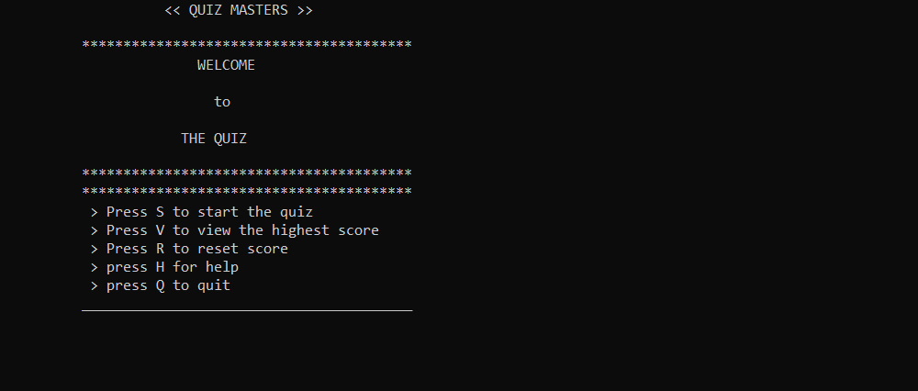

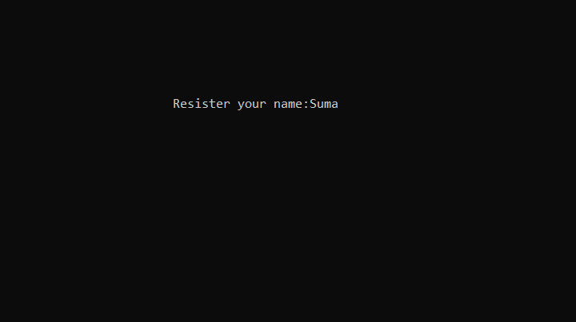

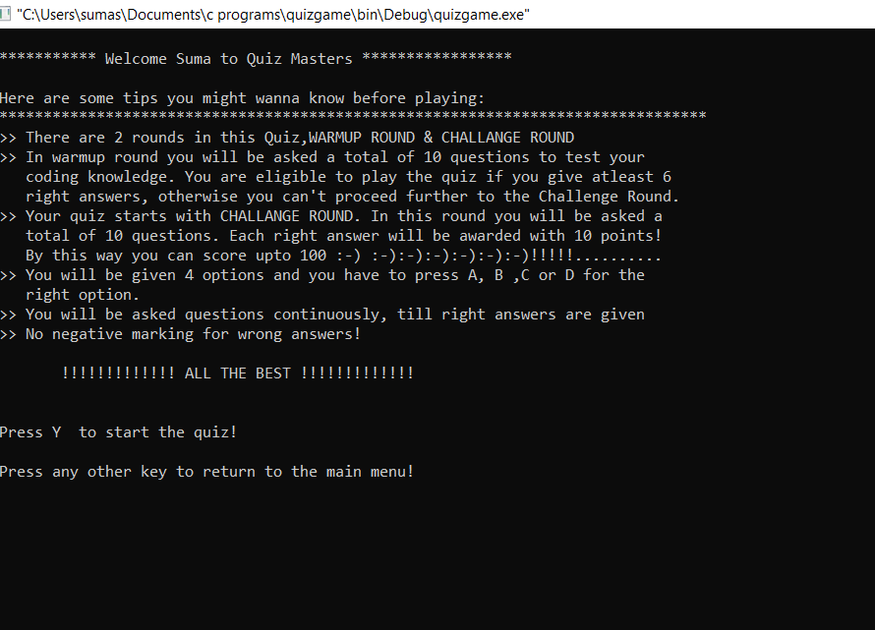

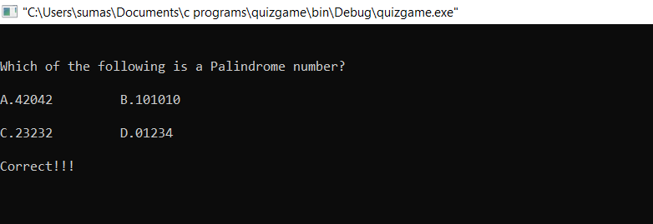

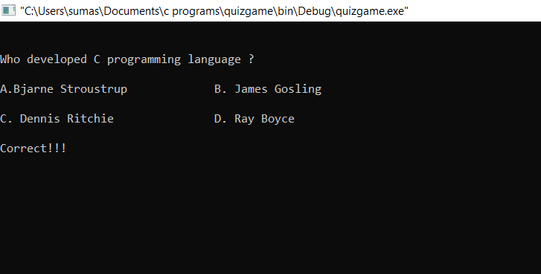

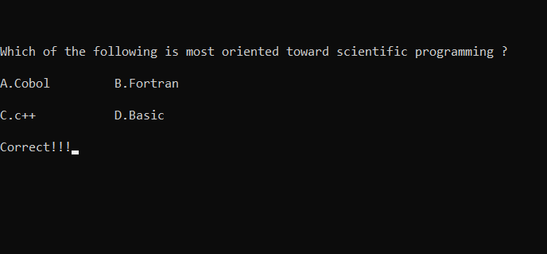

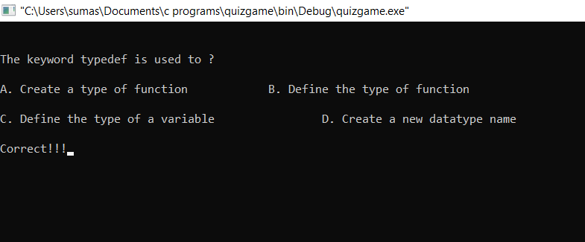

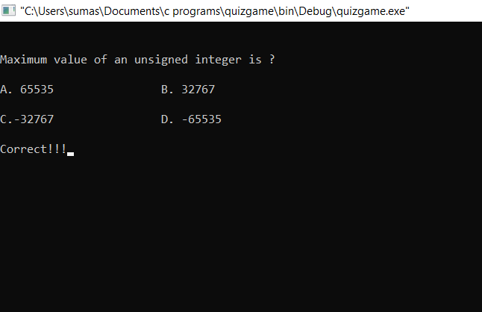

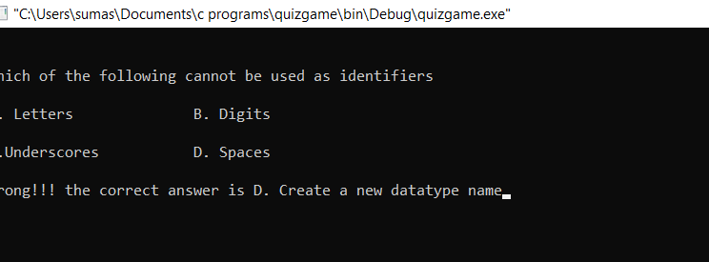

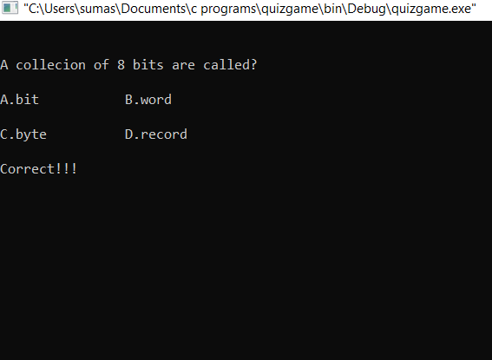

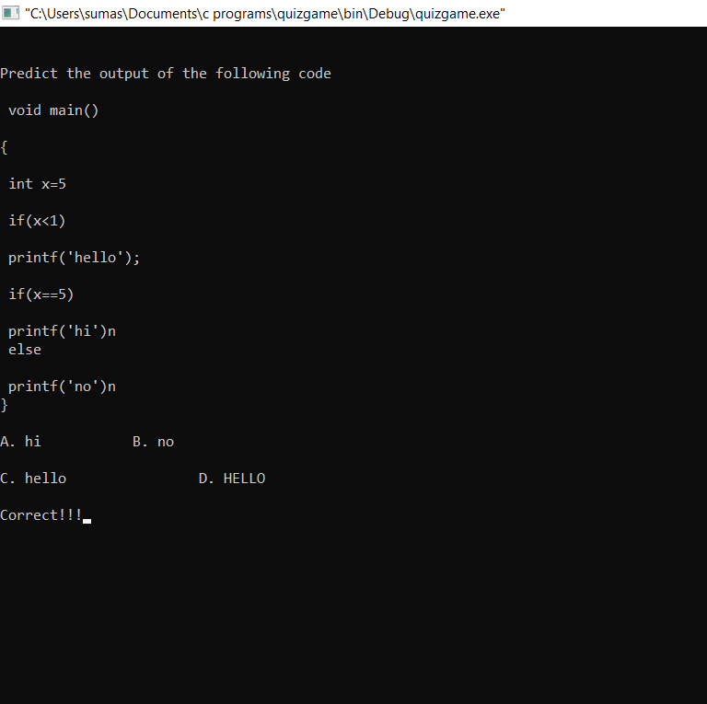

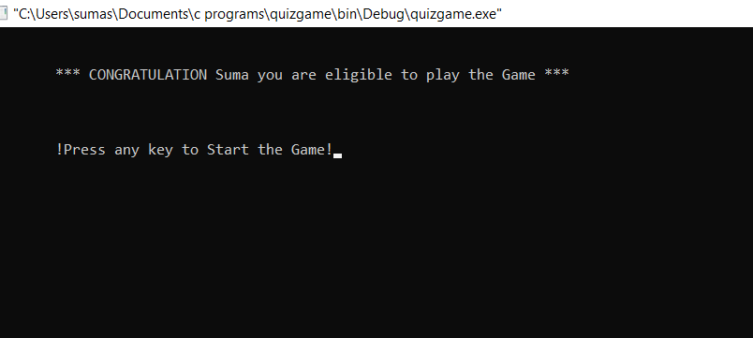

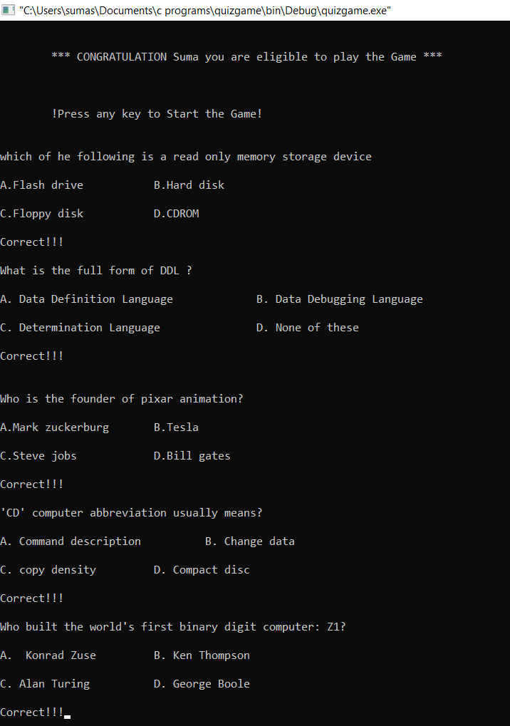

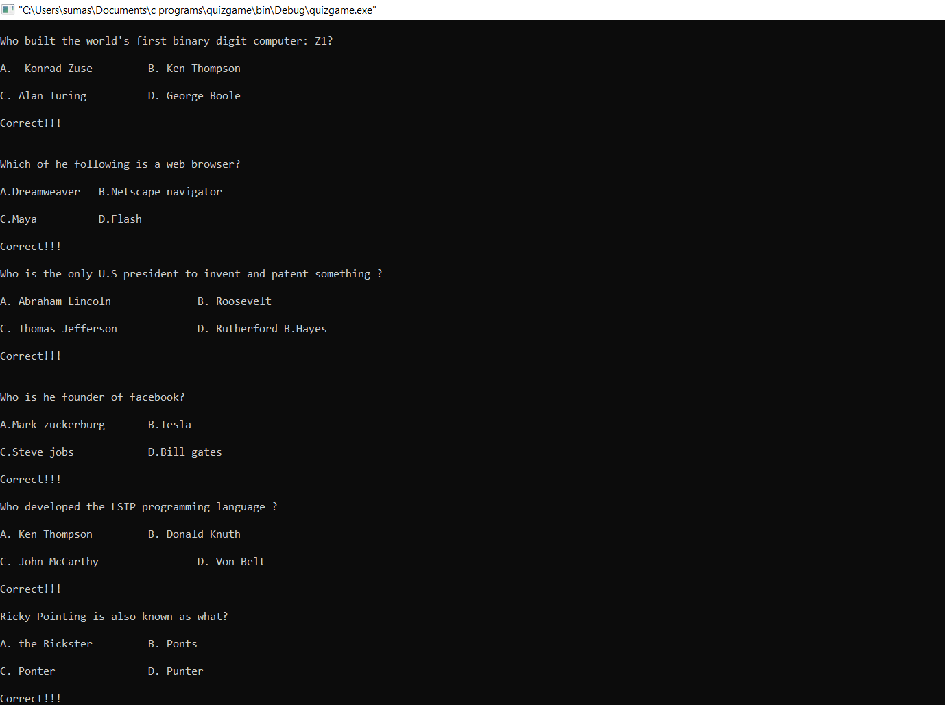

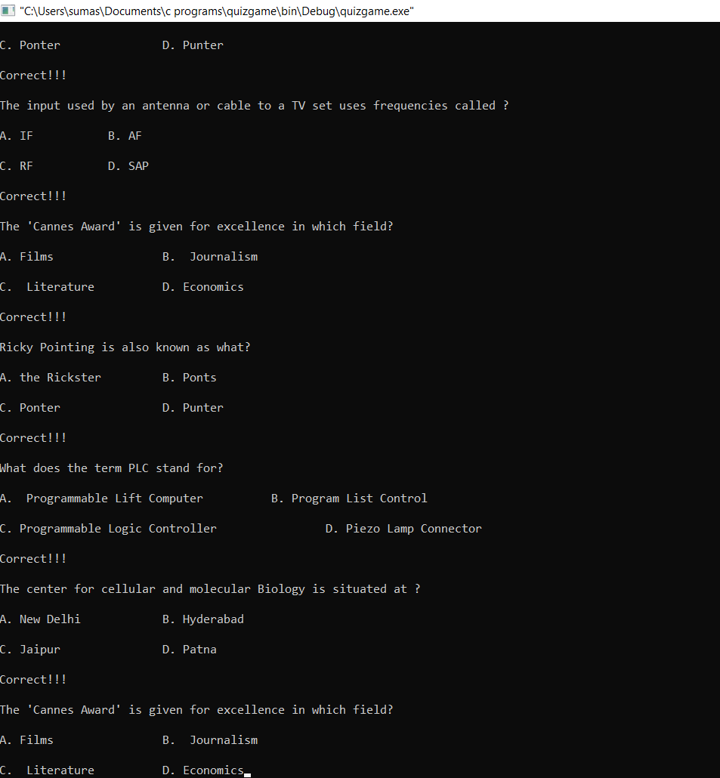

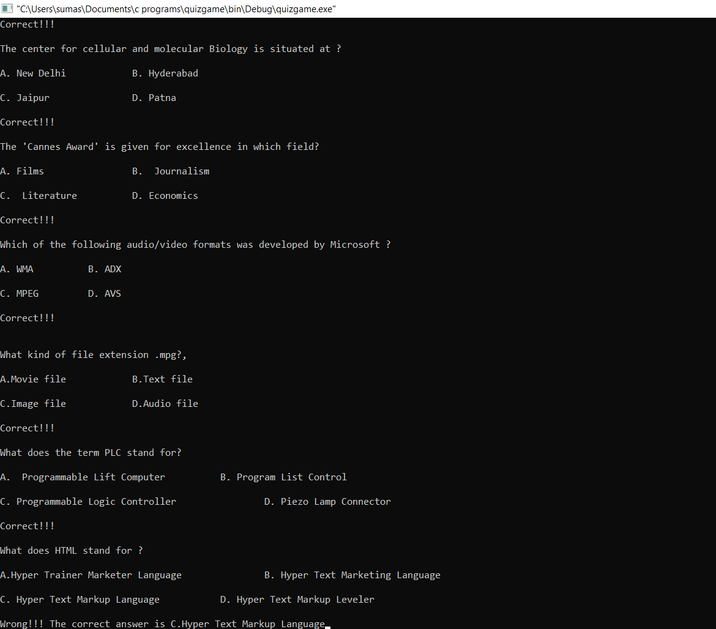

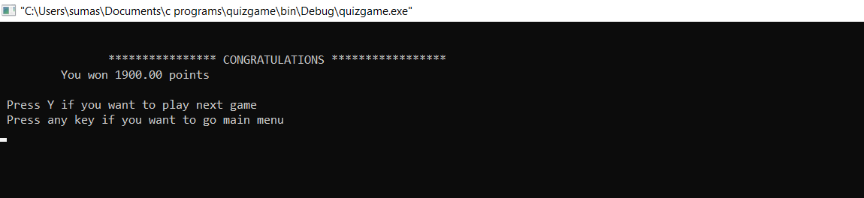

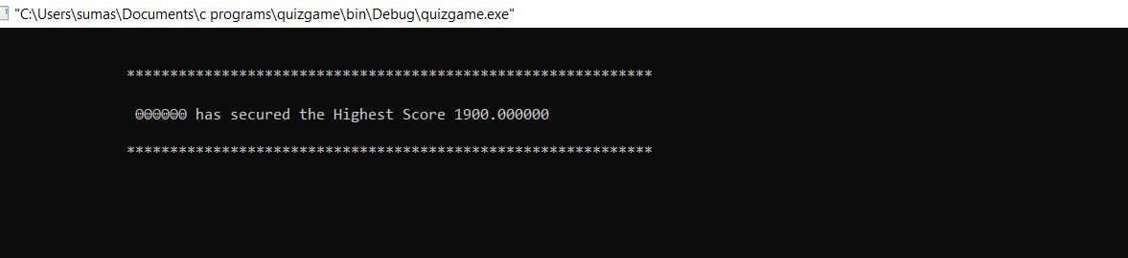

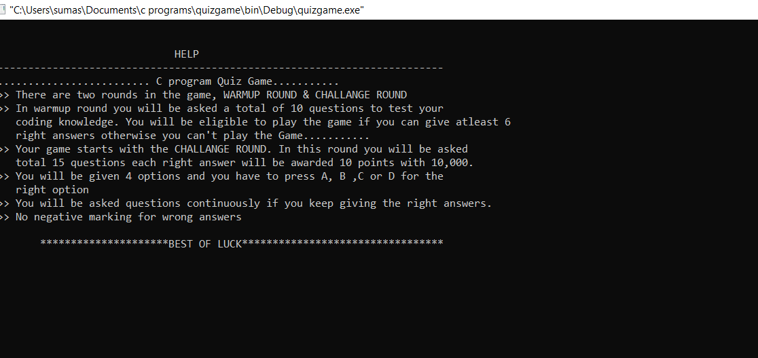

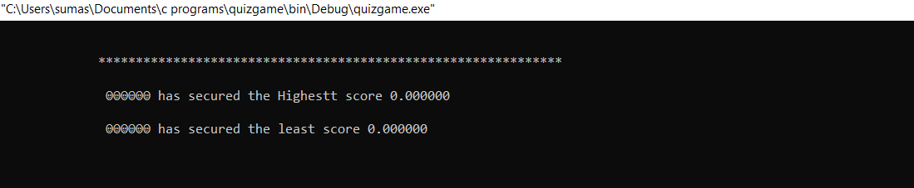

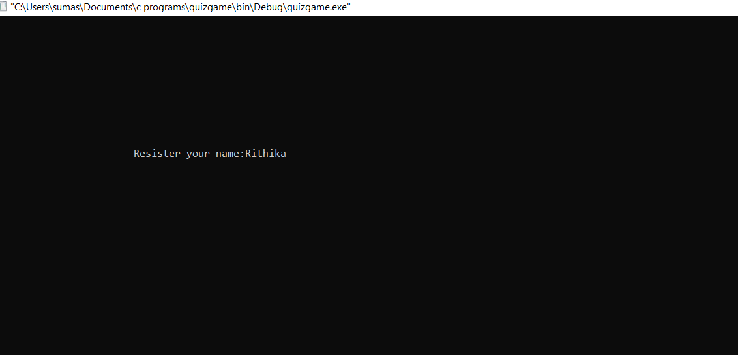

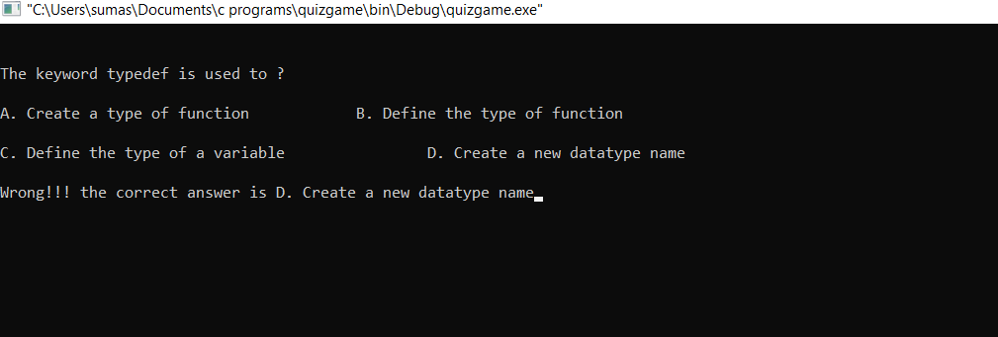

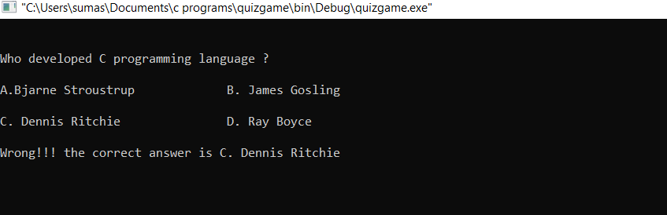

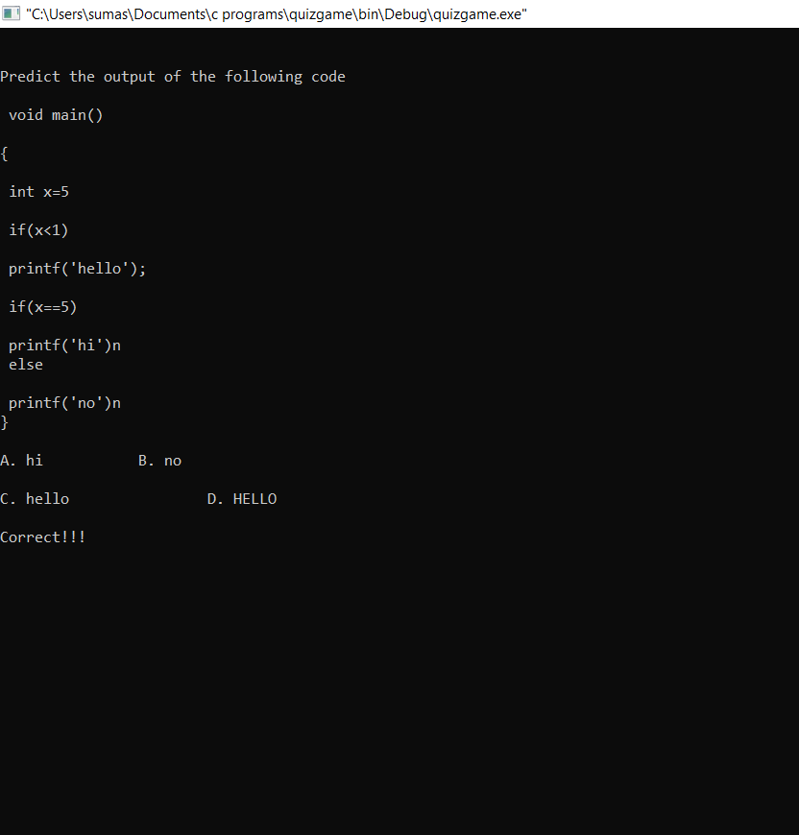

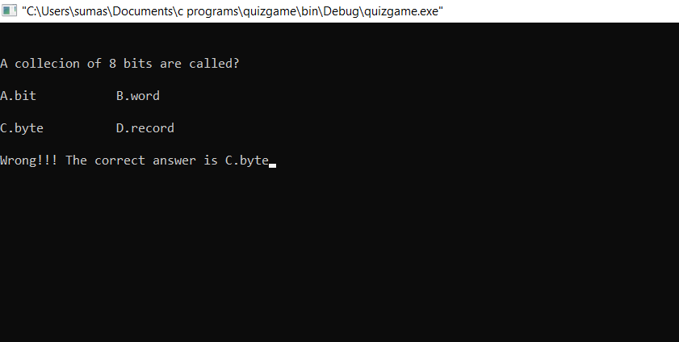

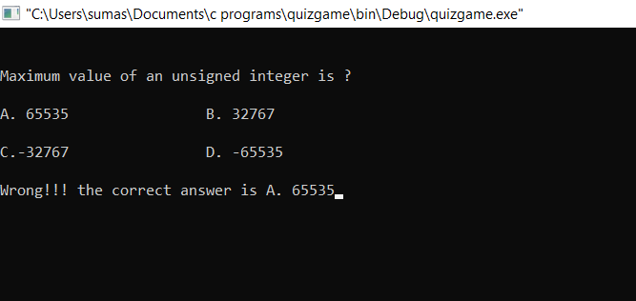

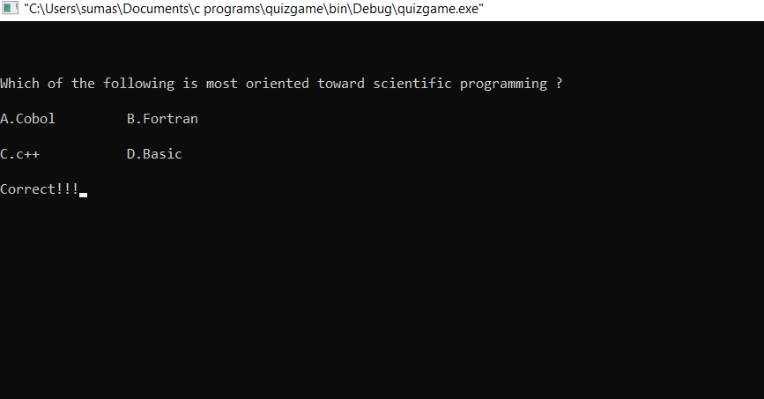

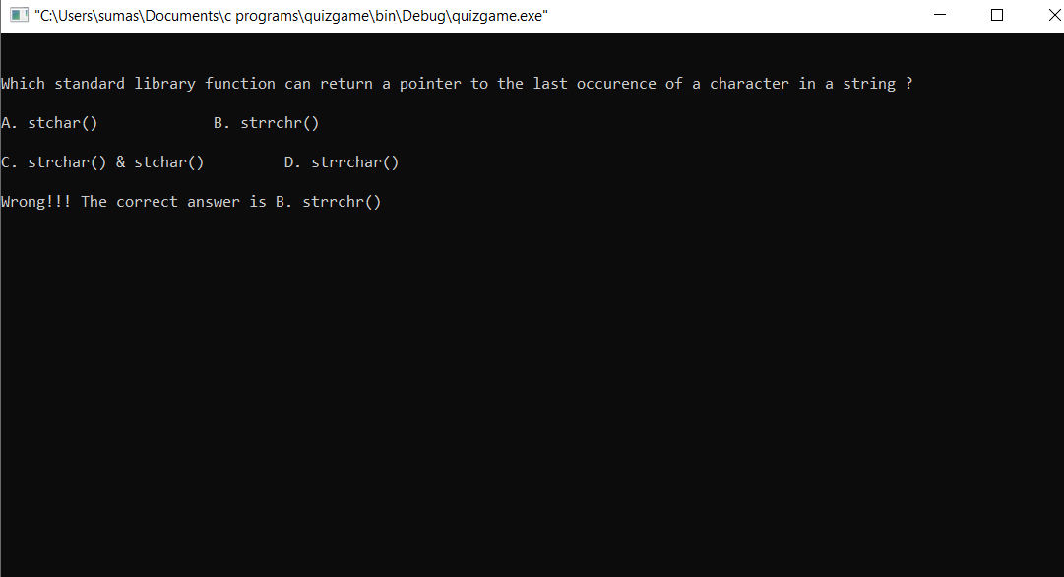

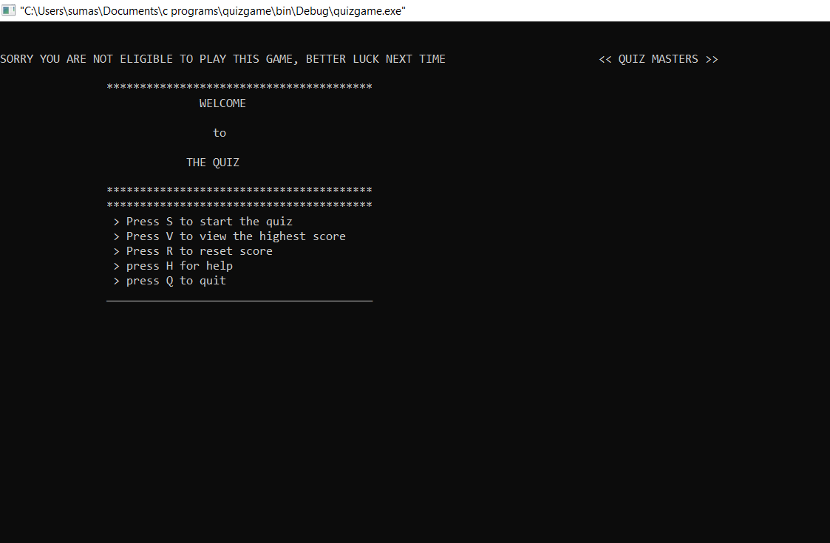

**What is the additional knowledge gained as a result of implementing this miniproject apart from the syllabus covered in the course programming for problem solving?**

Actually I am not good at files but by this project I learnt how to handle files even though I did succeed with my project but I tried and learnt how to use files .

**CONCLUSION AND FUTURE WORK**

All the data will be saved in the database. So, the administer can view all the data on time. This

system reduces manual works too.

This system will also be used in any competitive exams even to make tough competition with the

users.

The following section describes the word that will be implemented will future releases of the

software.

User Orders: Allow users to know about their scores and previous scores

Enhance User Interface by adding more user interactive features.

Provides random questions in the quiz / Day to Home page

**REFERENCES**

We referred google and our c textbook for the completion of project successfully.

The C Programming Language is written by Brian W. Kernighan and Dennis M. Ritchie. This book is

considered to be the best C programming book because it is written by inventors of C language. The

book explains the concept of C language in an easy manner and covers every concept in detail.

www.geeksforgeeks.org